Exercise 7
- List the names of 5 youngest employees in the company.
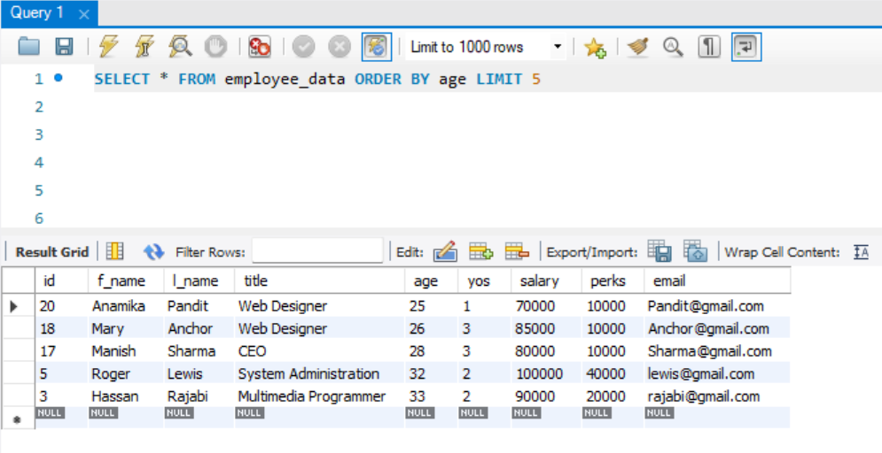
- Extract the next 5 entries starting with the 10 row.
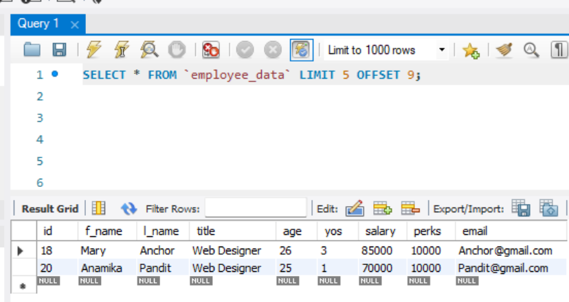
- Display the names and salary of the employees who draws the largest salary.
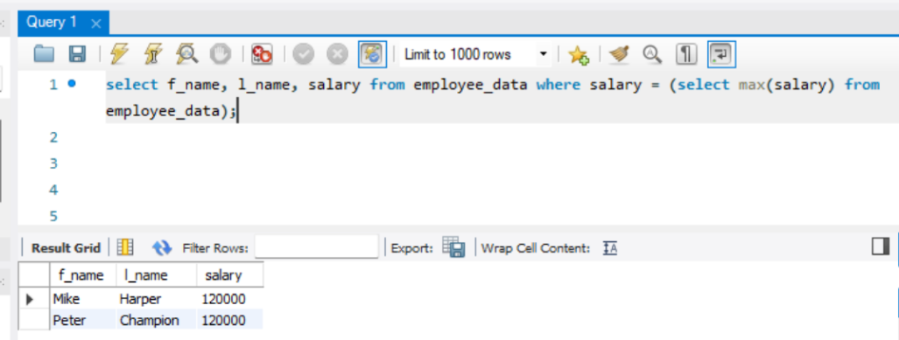
- What does the following statement display?
SELECT emp_id, age, perks from employees_data ORDER By perks DESC LIMIT 10;

Displays 10 rows of id, age and perks of the employees sorted by perks in descending order

